Subject
Advanced Machine Learning

Unit III

Genetic Algorithms

Assignment individual 3

Irene Valle Ares
This report describes, in detail, the implementation and training results of a Perceptron model using a Genetic Algorithm (GA) for binary classification, compared to the traditional training algorithm (Vanilla Perceptron). The experiment was conducted using the Wisconsin Breast Cancer dataset.
- Introduction and Methodology
The main objective of this experiment was to apply global search techniques, particularly Genetic Algorithms, to optimize the weights of a simple Perceptron. This approach contrasts with local search methods (such as hill climbing or steepest ascent) and with the traditional gradient descent used in the standard Perceptron.
  - Components of the Genetic Algorithm
In accordance with the requirements established in the theoretical sessions, the implemented Genetic Algorithm consists of the following components:
- Initialization Function: A random initialization based on a standard normal Gaussian distribution was used to generate the initial population of weight vectors.
- Algorithm Selection: Tournament Selection used, k equaling 3. This approach randomly picked k individuals from the population and picked the fittest one, making it a parent that ensures enough selective pressure, managing both positive and negative fitness numbers, too.
- Crossover Functions: I've also added two types which are picked randomly like half the time, during the whole reproduction thing.
- One-Point Recombination: A random spot in the genome, the weight vector, is picked, then, the parent's tails get swapped, and the offspring pops out.
- Uniform Recombination: Every gene gets a random decision (a coin toss really, for 50 percent), it decides which parent will pass it along which allows a blend of characteristics.
- Mutation Functions: Two variants were implemented that are randomly applied to the generated offspring:
  - Gaussian Mutation: Gaussian noise is added to the individual weights with a predetermined probability. It is a natural adaptation of the "bit-flip" mutation to represent traits with real values.
  - Uniform Mutation: Instead of positions being switched, it picks a weight, swaps it with a fresh random one. This really helps genetic stuff and escapes being stuck.
- Fitness function
Evaluating the caliber of everyone, the F1-Score (Macro) metric came into play. That specific metric got selected because it smartly weighs Precision plus Recall, and it is notably resilient towards probable dataset class imbalances.
- Experiment Results
For the experiment, we used the Wisconsin Breast Cancer dataset, already pre-standardized. 50 individuals formed a population, which evolved through 150 generations in the Genetic Algorithm, whilst the Vanilla Perceptron chugged along for 150 epochs.
  - Performance Comparison
The results from the test set are summarized below in this table:
METRIC | PERCEPTRON GENETIC ALGORITHM | VANILA PERCEPTRON
Accuracy | 0.9883 | 0.9474
F1-Score Macro | 0.9874 | 0.9443
Execution Time (s) | 13.8698 | 0.1246

  - Convergence Analysis
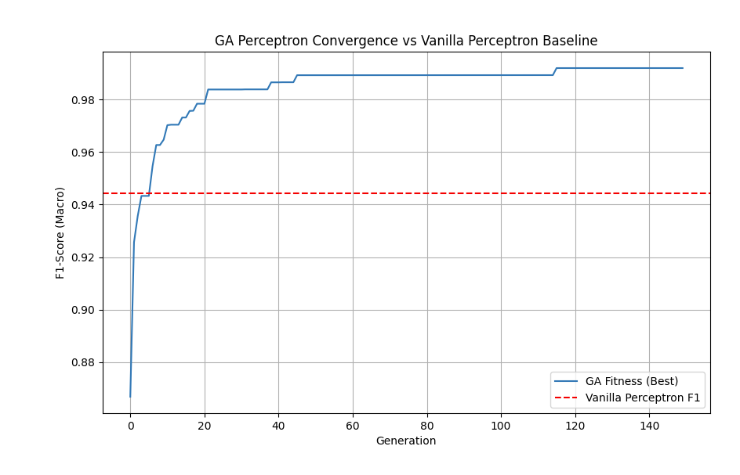
Now, the convergence plot clearly illustrates the fitness (F1-Score) changes, of the Genetic Algorithm's best individual across generations. Seeing' rapid gains in the initial twenty generations, hitting 0.9865, then flattening out. marginal changes happen after that, only reaching' 0.9866 by generation ninety. The dashed red line? That’s the final performance of the Vanilla Perceptron baseline.
- Conclusions
The outcome of the experiments unveils some striking distinctions between the two methodologies.
    - Accuracy and Broad Applicability:
The Genetic Algorithm really shone exceeding the Vanilla Perceptron on accuracy, 98.83% compared to 94.74%. Its F1-Score was also higher, at 98.74%, versus 94.43%. This really does hint that the GA's overall view of the playing field helped pinpoint better weights than the other one's simple, error guided moves.
    - Calculating time involved:
But that better accuracy had its price, right? Training the Genetic Algorithm ate up about 13.87 seconds, whereas the Vanilla Perceptron finished in like, 0.12 seconds. No surprise there the GA needs to do a whole group of things in its generations, like testing individuals, selection stuff, blending, changing and all that.
    - Looking around vs. getting the most out of it:
The GA, succeeding here, shows the power of bringing together the strategies: crossover, getting the best bits of what is good. And, mutation, exploring other avenues in the data thus avoiding a wrong stop. This can hurt more simpler, other methods.

To sum it up, employing Genetic Algorithms to train a Perceptron is a surprisingly efficient tactic indeed. This really boosts accuracy in intricate binary classification tasks like cancer diagnosis so long as the extended training duration is not a problem for the situation.

